KNN VS LOGISTIC REGRESSION PIPE FAILURE PREDICTION MODELS INTERPRETATIONS.

KNN PIPE FAILURE PREDICTION MODELS
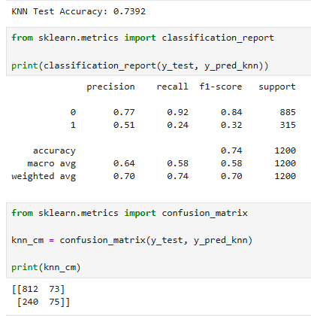

-- The total pipes predicted to not fail (PREDICTED 0) by the KNN model was 812 + 240 = 1052 pipes (column 1 summation)
-- The total pipes predicted to fail (PREDICTED 1) by the KNN model was 73 + 75 = 148 pipes (column 2 summation)
-- The total actual pipes that did not fail (ACTUAL 0) were 812 + 73 = 885 pipes (row 1 summation)
-- The total actual pipes that failed (ACTUAL 1) were 240 + 75 = 315 pipes
-- Focusing on failed pipes, the model correctly identified the number of failed pipes (predicted 1) to be 75 pipes.
-- To get the model’s PRECISION that is, “of all the pipes that were predicted to fail(148), how many/what percentage of them actually failed(75)” = (75 / 148) = 0.5068
-- To get the model’s RECALL that is, “of all the pipes that actually failed(315 pipes), how many/what percentage of them were correctly identified by the model” = (75 / 315) = 0.2381
-- The KNN Test Accuracy is 0.7392. However, our test set contains: 885 pipes that did not actually fail and 315 pipes that actually failed, which in total are 1200 pipes.
-- This translates to (885 / 1200) * 100 = 73.75% → for actual non-failure pipe observations and (315 / 1200) * 100 = 26.25% → for actual failed pipe observations, which does not match the recall value of 23.81%.
-- INTERPRETATION: The initial KNN model achieved 73.92% test accuracy, correctly classifying approximately 74% of the test observations. However, its low 24% recall for pipe failures indicates that it correctly detected only 24% of pipes that actually failed within 90 days, while missing approximately 76% of actual failures. Therefore, the model has limited effectiveness in identifying pipes at risk of failure.
-- CONCLUSION: The model should not yet be deployed as a standalone preventive-maintenance decision tool because of its low failure-detection capability. It could potentially be used as an exploratory screening model, but a model with substantially better failure recall would be preferable for prioritizing pipes for preventive inspection and maintenance.

LOGISTIC REGRESSION PIPE FAILURE PREDICTION MODEL

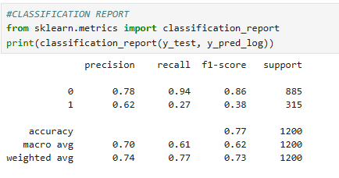
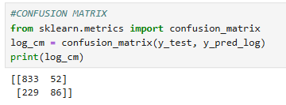
Predicted
0 1

Actual 0 833 52
Actual 1 229 86

-- We pay particular attention to class 1 which is the Pipe failure within 90 days.
-- PRECISION; Of all the pipes LR predicted would fail (52 + 86 = 138), how many/what percentage of them actually failed (86 / 138) = 0.6232
-- RECALL: Of all the pipes that actually failed (229 + 86 = 315), LR successfully identified ( 86 / 315) = 0.2730
-- Total pipes that actually did not fail (Actual 0) = 833 + 52 = 885 pipes (ROW 1 summation)
-- Total pipes that actually failed (Actual 1) = 229 + 86 = 315 pipes ( ROW 2 summation)
-- Total pipes the LR model predicted would not fail ( Predicted 0) = 833 + 229 = 1062 pipes (COLUMN 1 summation)
-- Total pipes the LR model predicted would fail (Predicted 1) = 52 + 86 = 138 pipes (COLUMN 2 summation)
-- Focusing on failed (Actual 1) row, the model incorrectly identified 229 pipes out of the 315 that actually failed as those that did not fail and correctly identified 86 pipes out of the 315 that actually failed as failed pipes.
-- Logistic Regression Accuracy: 0.7658
-- However, our test set contains: 885 pipes that did not actually fail and 315 pipes that actually failed, which in total are 1200 pipes.
-- This translates to (885 / 1200) * 100 = 73.75% → for actual non-failure pipes and
(315 / 1200) * 100 = 26.25% → for actual failure.
-- INTERPRETATION:The Logistic Regression model achieved 76.58% test accuracy, correctly classifying approximately 77% of the test observations. However, its recall for pipe failures was only 27%, meaning that the model correctly identified 27% of pipes that actually failed within 90 days while missing approximately 73% of actual failures. Therefore, although the model performed better overall than the KNN model, its current ability to detect pipe failures is limited and would require further improvement before being used as a standalone predictive-maintenance tool.

RECOMMENDATION: Test multiple thresholds to get the best threshold instead of the 0.50 threshold
-- FOR A PIPE FAILURE APPLICATION, I CHOSE 0.30. I would select Logistic Regression threshold = 0.30 because it has only 114 missed failures, compared with 148 at threshold 0.35.
-- Most importantly, we've reduced the number of missed failures from the original 229 (when threshold was 0.50) to 114 when threshold is 0.30

-- CONCLUSION: At threshold 0.30: If the model identifies a pipe as high-risk, there is approximately a 47% chance that it actually fails within 90 days. The model identifies approximately 64% of all pipes that actually fail within 90 days.

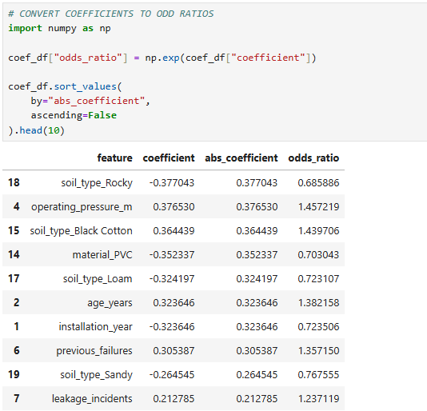
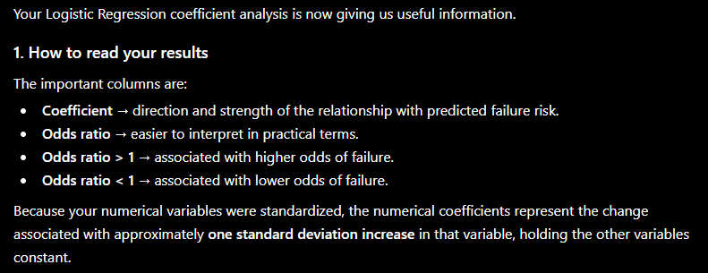
FEATURE | COEFFICIENT | ODDS RATIO | INTERPRETATION
soil_type_Rocky | -0.377 | 0.686 | Associated with lower failure odds relative to the reference soil type
operating_pressure_m | +0.377 | 1.458 | Higher pressure is associated with higher failure odds
soil_type_Black | +0.364 | 1.440 | Associated with higher failure odds relative to the reference soil type
material_PVC | -0.352 | 0.703 | PVC is associated with lower failure odds relative to the reference material
soil_type_Loam | -0.324 | 0.723 | Associated with lower failure odds relative to the reference soil type
age_years | +0.324 | 1.382 | Older pipes are associated with higher failure odds
installation_year | -0.324 | 0.724 | Later installation year is associated with lower failure odds, but interpret alongside age_years
previous_failures | +0.305 | 1.357 | More previous failures are associated with higher failure odds
soil_type_Sandy | -0.265 | 0.768 | Associated with lower failure odds relative to the reference soil type
leakage_incidents | +0.213 | 1.237 | More leakage incidents are associated with higher failure odds

THE ENGINEERING INTERPRETATION
-- Operating pressure has an odds ratio of about 1.46.That means a one-standard-deviation increase in operating pressure is associated with approximately 46% higher odds of failure, all else equal.
-- Age has an odds ratio of about 1.382. So a one-standard-deviation increase in pipe age is associated with approximately 38% higher odds of failure.
-- Previous failures Odds ratio = 1.357 This suggests that pipes with a history of previous failures tend to have higher predicted failure risk.
-- Leakage incidents Odds ratio = 1.237. This suggests that previous leakage problems are also associated with greater failure risk.

-- YOUR LOGISTIC REGRESSION SHOWS ASSOCIATION, NOT CAUSATION.
-- A better portfolio statement would be:-- "The model identified operating pressure, pipe age, previous failures, leakage incidents, and soil type as important predictors associated with failure risk."

CREATE A FINAL MODEL COMPARISON BETWEEN KNN AND LOGISTIC REGRESSION.
-- We'll compare: Accuracy, Precision, Recall, F1 - Score, ROC-AUC, False Negatives, False Positives, Engineering Usefulness
-- And then we'll turn the results into a proper portfolio conclusion and recommendations for the pipe-failure prediction project.

